[Date]

Gabriele Hunte

by Muffy Productions

Cloud Puffs

Comp 305-F2016 -Assignment – 01



Student Name: Gabriele Hunte

Student Number: 300833315

Date Created: 27/09/2016

Contents

# Version History

Initial Commit

Push of full game to GitHub.

Final commit

Reevaluation of gaming assets and addition of documentation.

# Game Description

***Cloud Puffs*** is about a lone fighter space jet protecting his planet from a self-reproducing demon who is out to conquer his world.

The player will have to ram into all the Muffy clones before they swarm him. Muffy will occasionally send bombs (or carry them, sometimes hidden) in order to hurt the player chunking away at the players 5 lives. The player can restore these lives with a health pack in the form of a gem that will appear in the game.

# Controls & Interface

The player has succeeded in his daily mission once he has destroyed 100 Muffy clones before he himself dies. Lives and Score will be shown in the top corners of the screen.

The player is allowed to move anywhere along the x-axis (left and right) using the arrows keys he can also venture off into space if he wishes but this will amount to nothing as he will not be defending against the shower of clones.

In the beginning and end of the game there will be Start and Restart buttons, respectively, for the player to begin the game.

Appropriate sounds will play on events such as player collision with other objects and player death, in addition level music will play throughout the gameplay and game over music at end.

Player’s Final Score count will be displayed at the end of the game win or lose.

# Wireframe

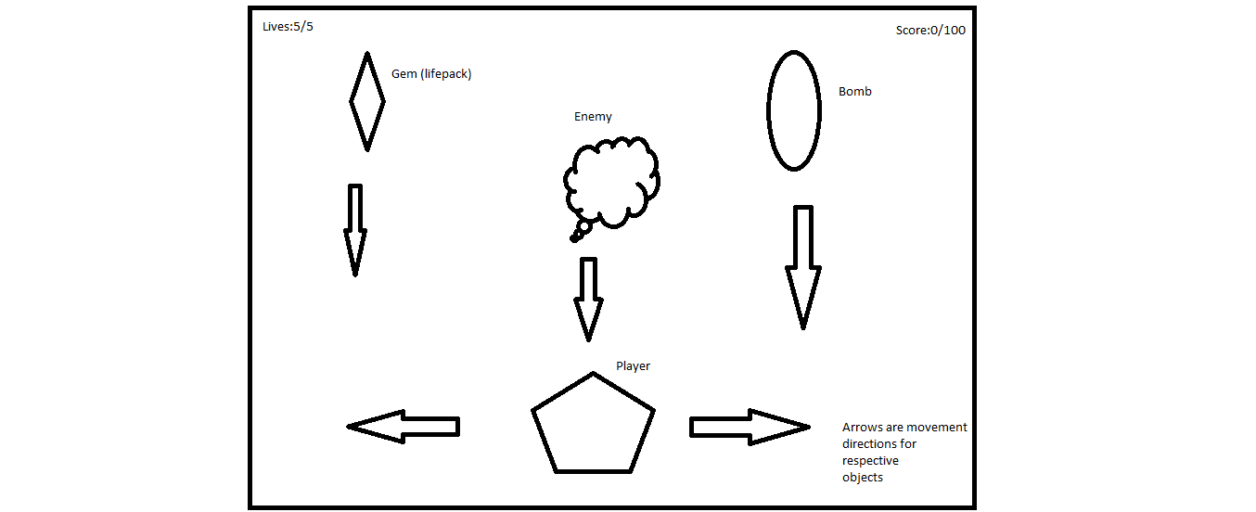

# Screenshots

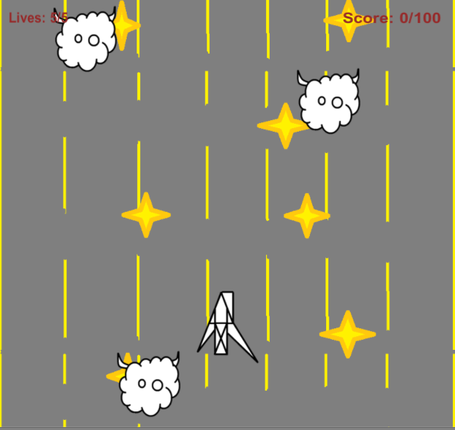

Fig.1 – Gameplay

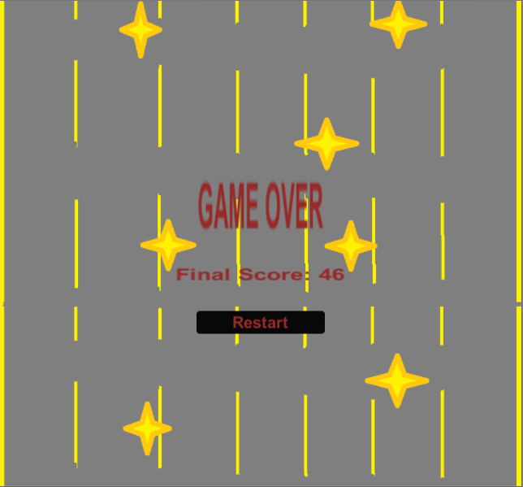

Fig.2 – Game Over Screen

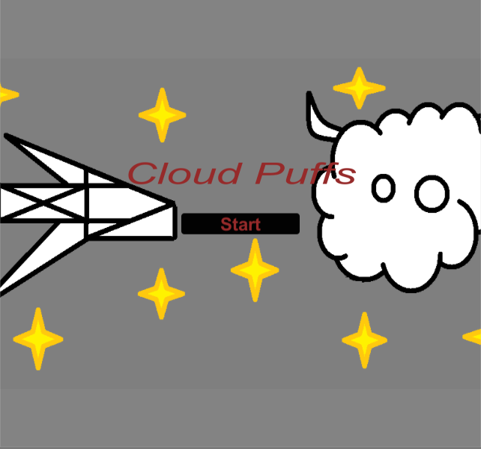

Fig.3 – Start Screen

# Sound Index

Coin (plays on collision with Muffy)

Level_theme (plays at all part of game play and start screen)

Smh_bump (plays when collided with a bomb)

Smb_gameover (plays at ending screen)

Smb_powerup (plays on collision with gem)

# Art Index

Muffy –



Player –

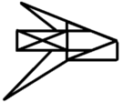

Bomb –

C:\Users\GABRIELE\Documents\COMP305Assignment-01\PtT\Protect the Town\Assets\Sprites\bomb.png

Gem –

C:\Users\GABRIELE\Documents\COMP305Assignment-01\PtT\Protect the Town\Assets\Sprites\gem.png